|  |
| --- |
| 新东方在线英语学习 |
| 新概念 1 册 |
| Lesson25-26 |



扫一扫。更多有趣的英语资讯。

# Lesson 25 单词讲解

1. Mrs.：夫人mei sei s
2. kitchen：厨房

in the kitchen

1. refrigerator：电冰箱fridge fu rui zhi
2. Rui fu rui zhi rui d er
3. right：右边 n.

on the right

桌子在右边。

The desk is on the right.

1. left ：左边 n.

on the left

床在左边。

The bed is on the left.

1. electric : 带电的，可通电的yi lai ke chui ke

an electric cooker an electric shaver

1. cooker ：炉子，炊具
2. middle ：中间 n. mei dou

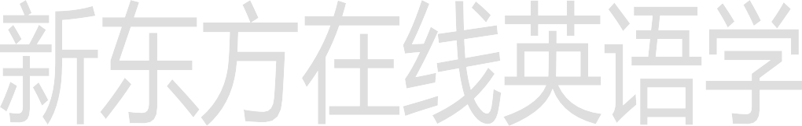in the middle of 在…的中间桌子在屋子的中间。

The table is in the middle of the room.

1. of （属于）……的 prep.
2. room n. 房间

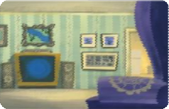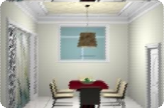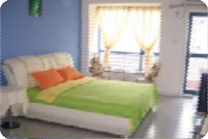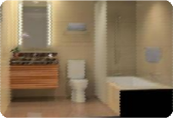

living room dining room bedroom bathroom

起居室 客厅 餐厅 dai ning room

1. cup : 杯子
2. Mrs. Smith's kitchen is small.

第一句——总述

1. 描述物体的方式：

There is … in the kitchen. The … is blue.

It is on the left.

# Lesson 25 课文讲解

所在位置，颜色，具体位置，状态所在位置，颜色，具体位置，状态

卧室里有一张床，是绿色的，它在屋子的中间，上面很干净。

There is a bed in the bedroom. The bed is green.

It is in the middle of the room. And it is very clean.

所在位置：there be 句型颜色：It is+ 颜色

具体位置：on the right\left, in the middle of…

状态: It is clean\ empty\ large\ small…

1. 冠词用法复习

There is an electric cooker … There is a table…

There is a bottle … There is a cup …

There is a refrigerator …

总结：初次出现，不了解，不确定，用不定冠词 a\an,

再次出现，了解了，确定了，用定冠词 the.

那有一个人，这个人穿着蓝色的衣服，他是一位机械师。

There is a man.



The man is in blue.

And he is a mechanic.

**Lesson 25 语法讲解**

1. There be 句型
   1. 构成： There be+ (is, are)+地点
2. 用法：

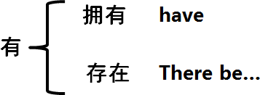

1. 分类：

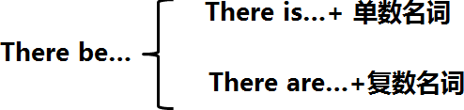

1. 翻译**：**

There is one in my heart. 我心里有一个人。

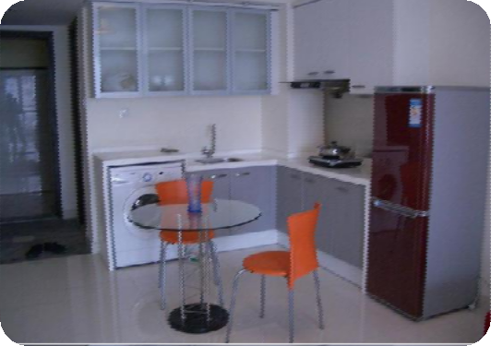

There is a cooker in the kitchen. There is a fridge in the kitchen. There are two chairs in the room.

There is a table in the middle of the room.

# Lesson 26 单词句型讲解



1. where: 哪里
2. in: 在…里面

Where is it？

**Lesson 25&26 知识拓展**

介词 in

恋爱

他恋爱了: He is in love.

1. 三合一
2. 综合能力部
3. in+ 语言，用…

Please in English.

1. in + 颜色

穿着…颜色的衣服

The girl is in red.

1. in cash: 使用现金

pay in cash

1. in the rain: 冒雨

They walk in the rain.